

School of Computer Science and Engineering

INTERNET PROGRAMMING PROJECT REPORT
(Project Term January-May 2021)

PROJECT REPORT ON

Gold’s Gym Website

Submitted by

Sl. No. | Name of the Student | Regn. No. | Scection | Semester
 | Pathala Sowmya Varshini | 12007929 | K20NC | 2
 | Shaik Jiyaul Haq | 12007448 | K20NC | 2

Introduction to Project
We have done a project on Gym website. This project is designed to facilitate a gym and fitness center. This website is designed in such a way that every customer can easily access the information about the gym. It also provides the facility of submitting any kind of query.
- Objective of the Project: The main objective of this project is to design and develop a new and attractive website on Gold’s Gym and to provide the following features to the customer: complete information about the gym, facilities that are provided to the costumers, location of gym and contact details to keep in touch with members of gym, packages and amazing offer and it also contain a form where you can submit all your queries.
- Subject Out Comes: The website contains four pages: Home, About, Packages, and Contact Us. Home Page: It contain a logo of Golds Gym and navigation buttons that connects to other web pages and it also contains some text which tells you the importance of physical fitness.
About Page: This page gives you the basic information about the gym. To get more information about the gym just click on button “More details”, it will take you to browser where the complete information and history about the gym is available. This page also contains a video showing the facilities of gym. Through this video customers can view the facilities of gym, products and all the advanced equipment of company that they are going to use.
Package Page: This page contains the details of Prices and Plans of gym. It gives complete idea to the customer about all the packages, which are provided by the gym management. Customers can also get the information about the training that they are going to get. Every package has different prices, Customer can choose any of the package as per their convenience.

Contact Us Page: This page contains the details of Gym members like Name, Contact Number, location, Email Id. Costumers can easily contact the members of gym and can keep in touch with them. This page also contains a form. You need to fill your details and can submit any type of query by just clicking on the send message button.
FAQs: This page contains some frequently asked questions about Gold’s Gym. These are general question asked by many of the customers. Customers can clarify their most of their queries by referring those questions.
- Pages Developed By:
Sl. No. | Name of the Student | Regn. No. | Page Content(s)
 | Pathala Sowmya Varshini | 12007929 | Home, About Us,
 | Shaik Jiyaul Haq | 12007448 | Contact Us, Package

Results:
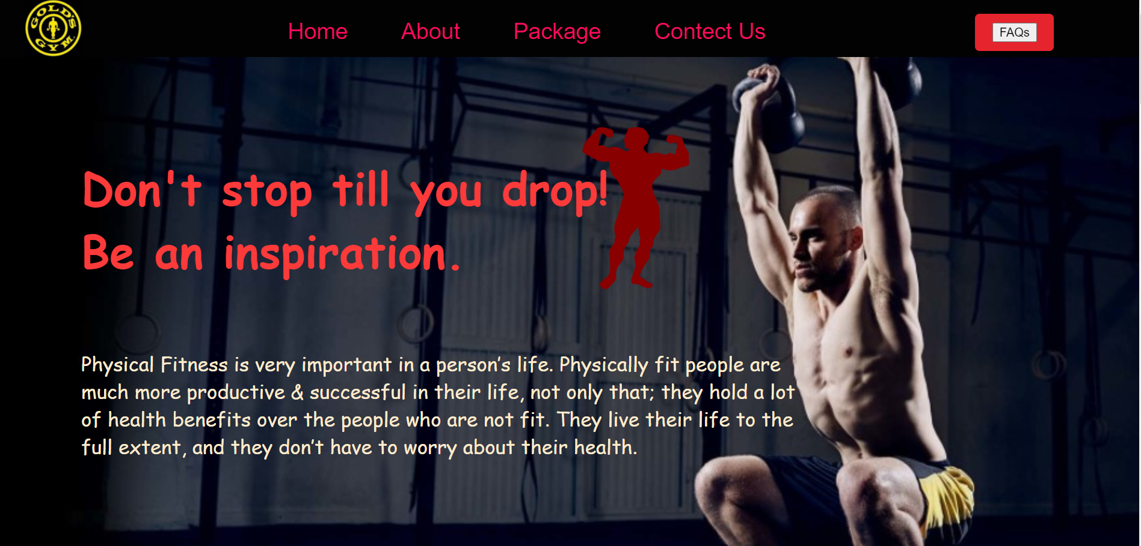
Home Page

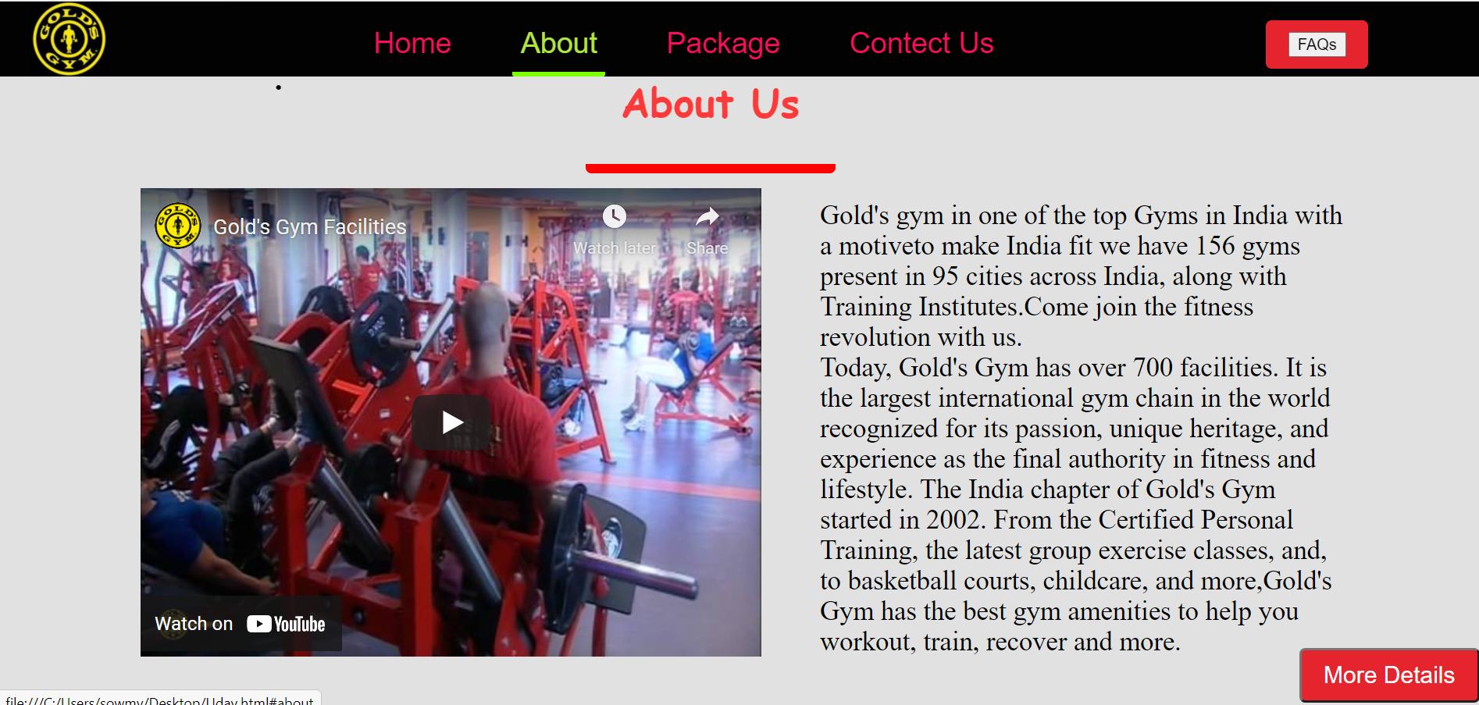
About us

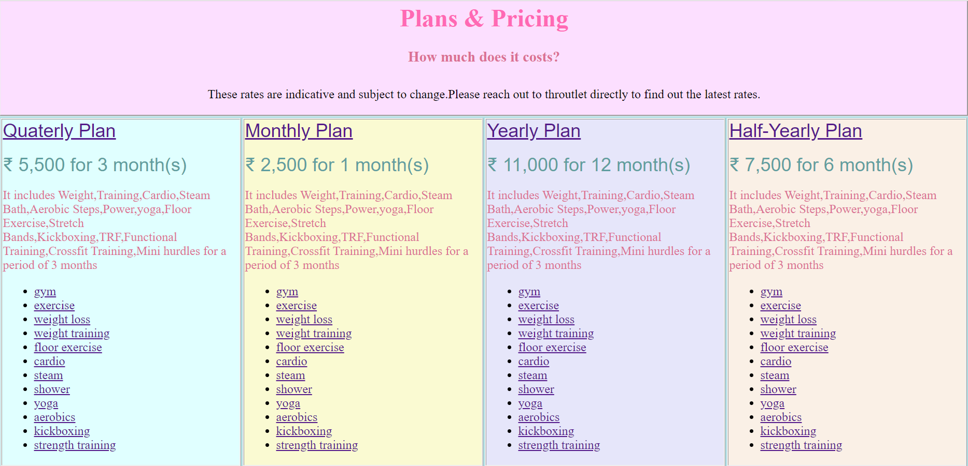
Packages

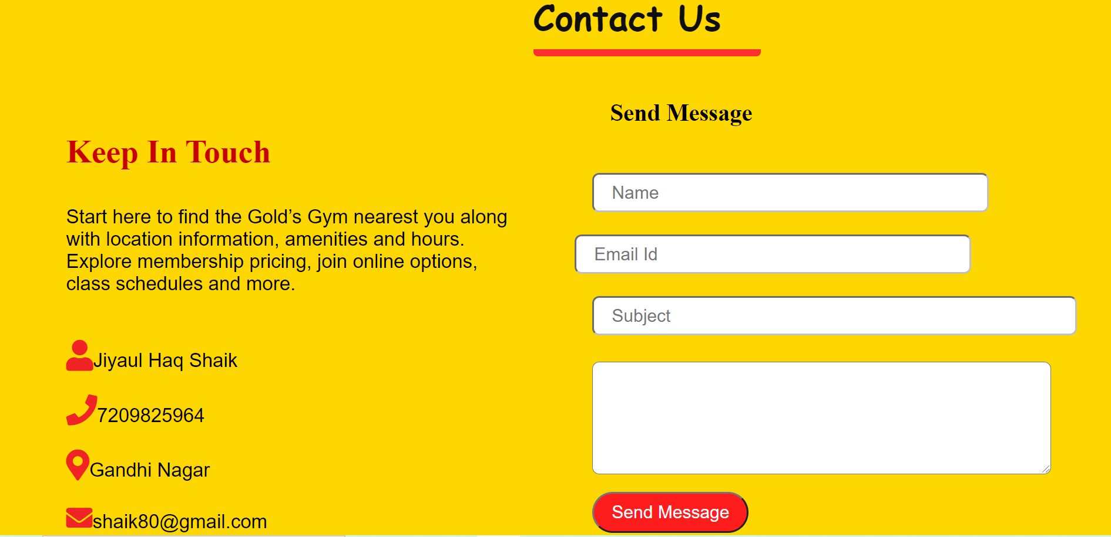
Contact Us
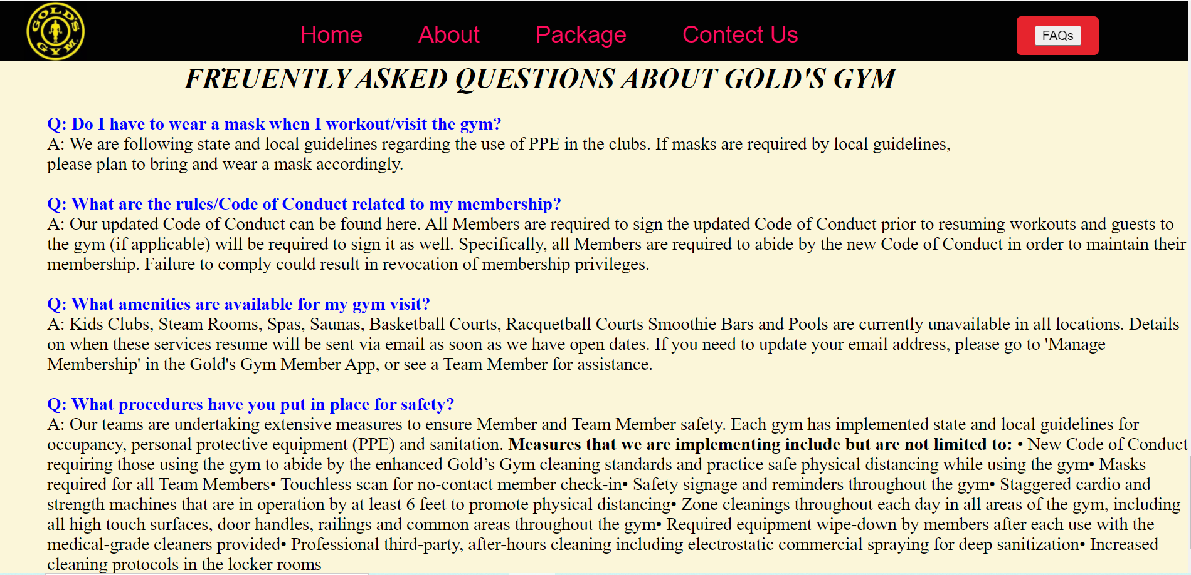
FAQs

Conclusion and Future Development: The main purpose of the website is to support the company business and to reduce the consumption of paper. In addition, to develop a system that can improve the business function and involve the customer to use the system. Provide easy way to customer to save time and take easy decisions to join the fitness club referring through online information system. It also increases the profitability of the company and be able to compete with their competitors.

